**DATA MODELLER ER-DIAGRAMS:**

* **B.Rishitha, 192324130**

**Student with course registration:**

Logical model:

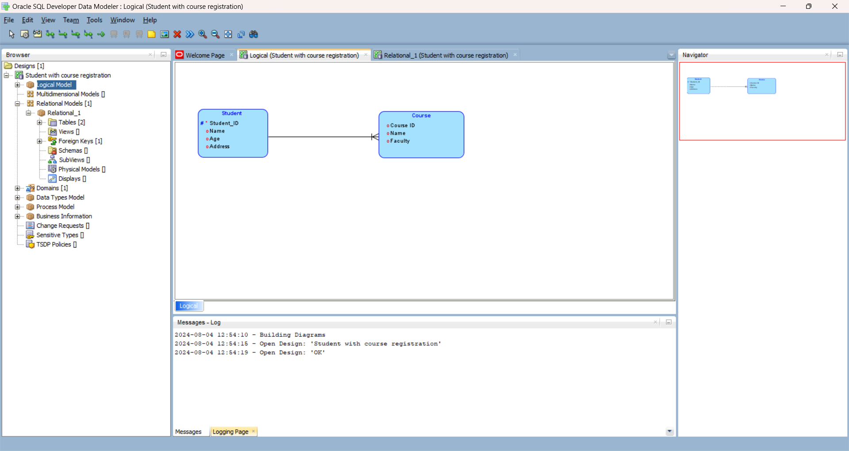

Relational model:

